Student Getting Started Guide
TABLE OF CONTENTS
CREATING A DAVIS EDGE ACCOUNT ........................................................................................................ 3
EXISTING DAVISPLUS MEMBERS ............................................................................................................. 4
RESETTING PASSWORDS ........................................................................................................................ 4
ACCESS CODES........................................................................................................................................ 5
CLASS ID ................................................................................................................................................. 6
SUCCESS CENTER .................................................................................................................................... 7
ASSIGNMENTS ........................................................................................................................................ 8
ASSIGNMENT NAME .............................................................................................................................................. 8 START AND END DATES ......................................................................................................................................... 9 STATUS ............................................................................................................................................................... 9
GRADE ................................................................................................................................................................ 9 TIME SPENT ......................................................................................................................................................... 9
ACTION ............................................................................................................................................................. 10
TIMED ASSIGNMENTS ........................................................................................................................... 10
ASSIGNMENT CLOCK ........................................................................................................................................... 10
OUT OF TIME ...................................................................................................................................................... 11
ANSWERING ASSIGNMENT QUESTIONS ................................................................................................ 11
ASSIGNMENT FEEDBACK....................................................................................................................... 12
DISCUSSION FORUM ............................................................................................................................. 12
PRACTICE QUIZZES ............................................................................................................................... 12
CREATE A QUIZ ................................................................................................................................................... 13 PRACTICE QUIZ BUILDER ...................................................................................................................................... 13 QUIZ NAME ....................................................................................................................................................... 14 COURSE TOPIC OR CONCEPT ................................................................................................................................. 14 QUESTION SIZE AND TYPE .................................................................................................................................... 14 TAKE A QUIZ ...................................................................................................................................................... 15
QUIZ FEEDBACK ................................................................................................................................................. 15
COMPREHENSIVE EXAM BUILDER (FOR NCLEX-RN®/NCLEX-PN® VERSIONS ONLY) .............................. 16
SUCCESS LEVEL GOALS ......................................................................................................................... 17
ACCESSING SUCCESS LEVEL GOALS ........................................................................................................................ 17 SUCCESS LEVEL GOALS TAB .................................................................................................................................. 17 CREATE A PRACTICE QUIZ ..................................................................................................................................... 17
BUILD THE QUIZ ................................................................................................................................................. 18
FEEDBACK REPORT ............................................................................................................................... 18
ACCESS FEEDBACK REPORT .................................................................................................................................. 18
CREATE A QUIZ BASED ON AREAS OF WEAKNESS ..................................................................................................... 19 REVIEW MODE ....................................................................................................................................... 19
TIPS FOR SUCCESS ................................................................................................................................ 20
GRADEBOOK ......................................................................................................................................... 20
E-BOOK (FOR CERTAIN PRODUCTS)....................................................................................................... 22
TECHNICAL SUPPORT ........................................................................................................................... 24

CREATING A DAVIS EDGE ACCOUNT
Davis Edge is web based and compatible with Internet Explorer 9.0 or greater and the latest versions of Mozilla Firefox, Google Chrome, and Apple Safari. This program utilizes responsive design and provides full functionality on Windows, Mac, Android or iOS computer, tablet, or smartphone.
Creating an account only takes a moment or two. Please note that if you are an existing DavisPlus member, you do not need to create a new account. Your DavisPlus account credentials will work here.
To begin, go to www.DavisEdge.com and click the “Login / Join” button.
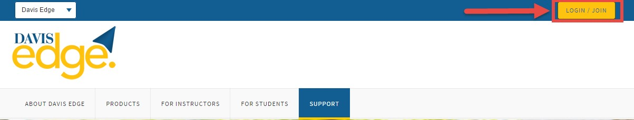
Click the “Create Account” button.

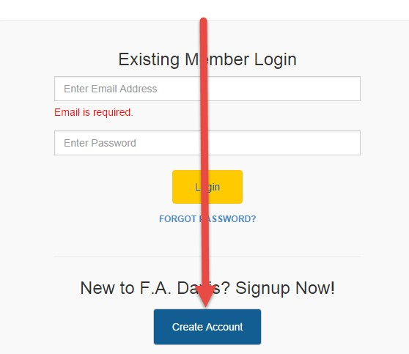
Enter your account credentials:

- Enter your email address
- Create your password
- Enter your name
- Enter your school information
- Click the “Create Account” button
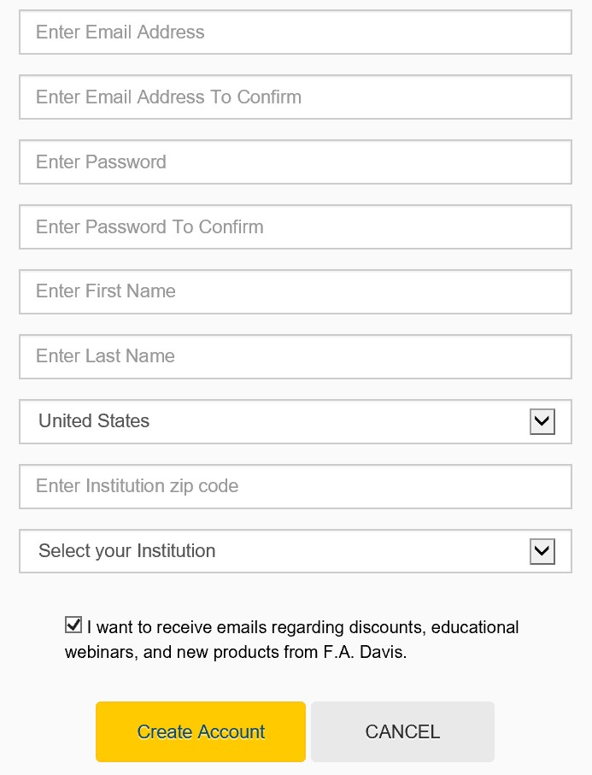

EXISTING DAVISPLUS MEMBERS
Once you have created an account, log into Davis Edge by clicking the “LOGIN / JOIN” link, located in the top right corner of the screen. Enter your email address and password then click the “Login” button.

RESETTING PASSWORDS
You can reset your password by clicking the “FORGOT PASSWORD” link, entering your email address, and clicking “SEND RESET LINK.” A link to reset your password will be emailed to you. If the email doesn’t arrive, please check your spam folder.
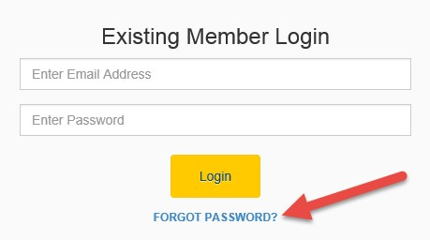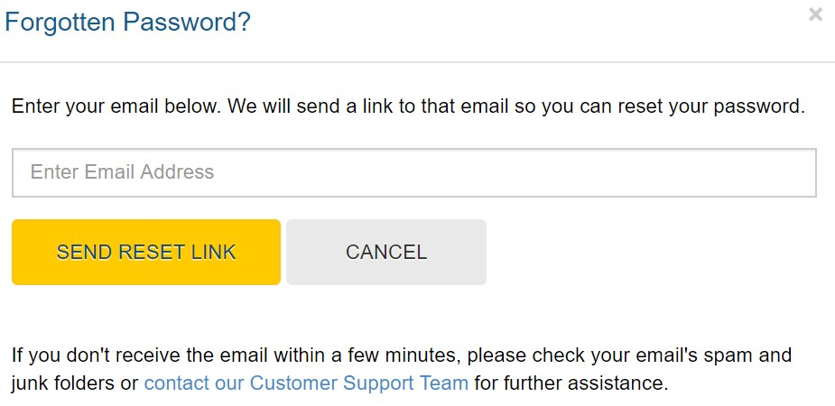
You can change your password at any time by going to the “My Account” area of Davis Edge.
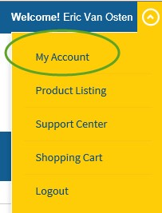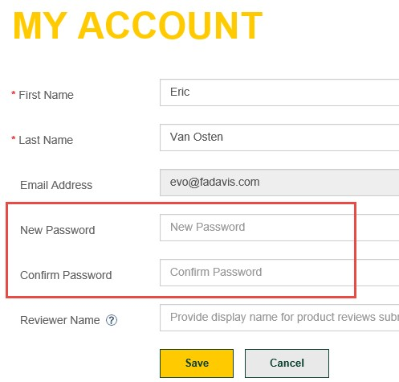

ACCESS CODES
After you have successfully created the account, you should be taken directly into the site. However, you still need to enter an Access Code to work and utilize the product.
A Davis Edge Access Code is can be obtained by: purchasing a Davis Edge Access Code Folder at the bookstore, or purchasing an Access Code at DavisEdge.com.
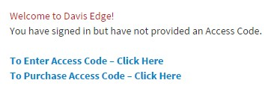

CLASS ID
You must enter your instructor’s unique Class ID number in order to access your instructor’s class, take your instructor’s assignments, and submit work to your instructor’s gradebook. The Class ID will be
provided to you by your instructor. Class ID: A184BC9847
this is for RNSG 2414 Spring 2019.

You will enroll in 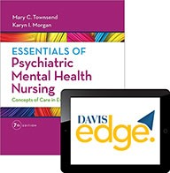
To enter a Class ID after you have created a Davis Edge account: (1) go to the bottom of the page and click on the “Insert Class ID” link, (2) enter the Class ID and click the “Submit” button. If you are joining more than one class, repeat these steps for each new class you need to join.
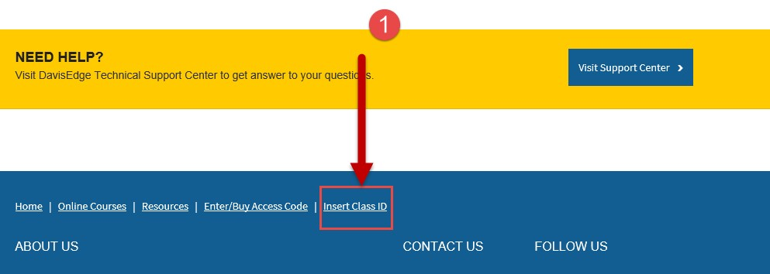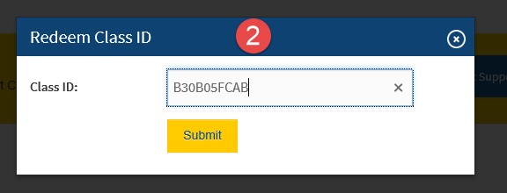

After you have entered the Class ID number, your instructor will admit you into the class. Please note that work conducted outside of your instructor’s class will not be reported to your instructor’s gradebook.

Class information will be displayed on the Success Center after your instructor admits you into the class. Note: if the instructor chose to admit students automatically, you will have instant access to the class.

SUCCESS CENTER
If you have used Davis Edge for only one class or product, your Success Center automatically opens each time you log into Davis Edge. There are several different functions available in the Success Center, which will be reviewed on an individual basis within this manual.
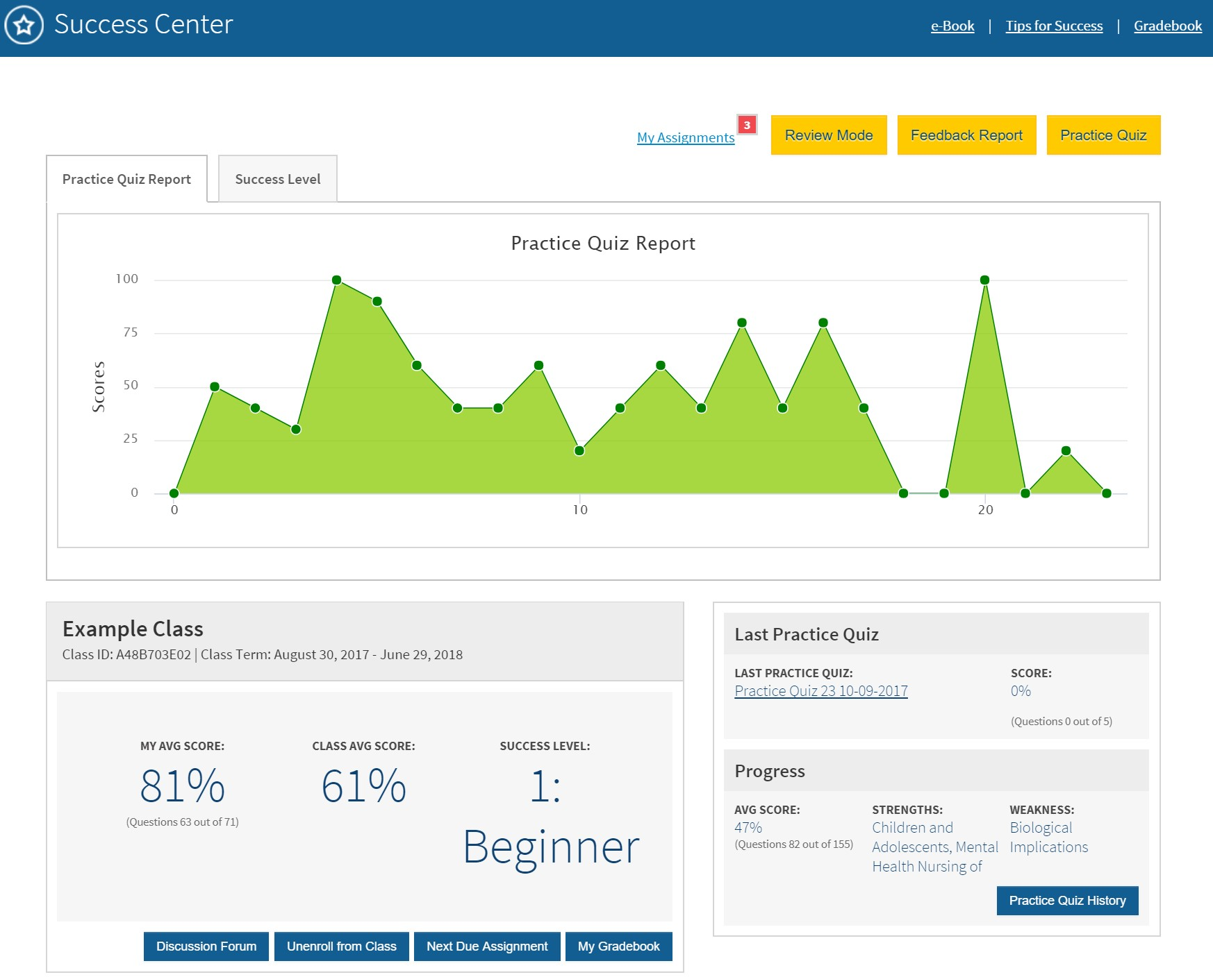

ASSIGNMENTS
Assignments are created by the instructor and graded. Assignments may be timed and have “end dates.” If students miss an assignment’s “end date,” a grade will not be submitted to the instructor’s gradebook.

To access your assignments, click on the “My Assignments” link on the Success Center page.
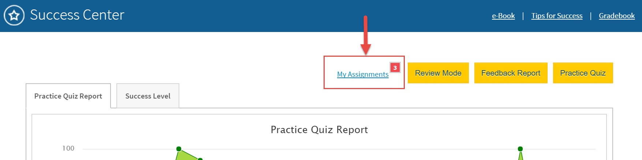

After you click on the My Assignments link, the “Class Assignment” tab will open. This page shows all assignments created by the instructor.
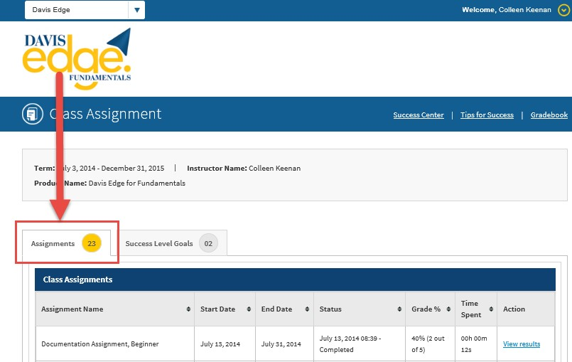

Assignment N
ame

Each assignment will be named.

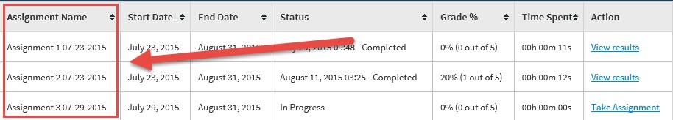

Start
and End
D
ate
s

The Assignment “Start Date” is the date that the instructor made the assignment available. The Assignment “End Date” is the last available day to complete the assignment. Work completed after the end date will not be submitted to the instructor’s gradebook.
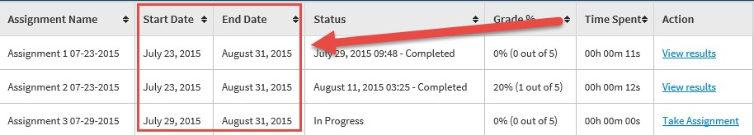

Status

The assignment “Status” shows whether students have started or completed an assignment.
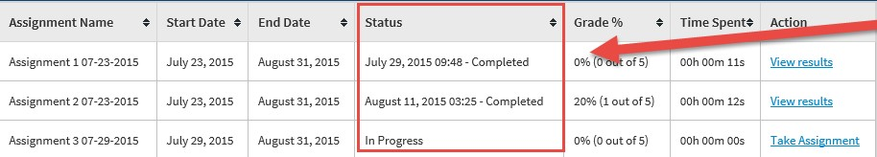

Gr
ade

Grades will be displayed for each completed assignment.
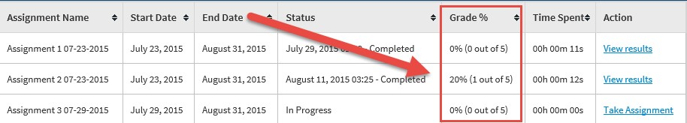

Time Spent
The “Time Spent” column will display the time you have spent on each assignment.

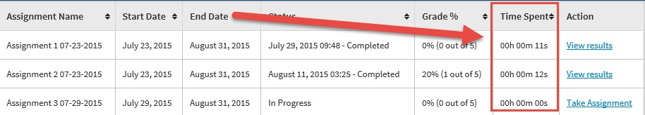

Action

Under the “Action” column, you can “View Results” of completed assignments or open the assignment by clicking “Take Assignment.”
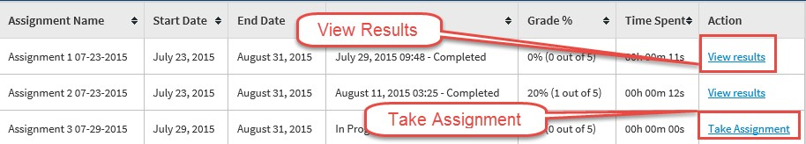

TIMED ASSIGNMENTS
Your instructor may set a time limit on an assignment. If an assignment is timed, you’ll receive an alert when the assignment is opened.
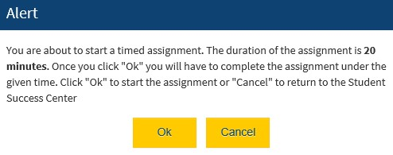

Assignment
C
lock

A clock will be displayed at the bottom of the screen for timed assignments.

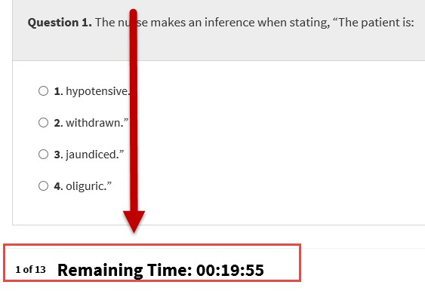

Out of
T
ime

If an assignment is not completed within the allotted time, an Alert message will announce that time has expired.

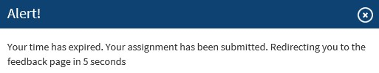

ANSWERING ASSIGNMENT QUESTIONS
To submit an answer, (1) select the answer, and (2) click the submit button.
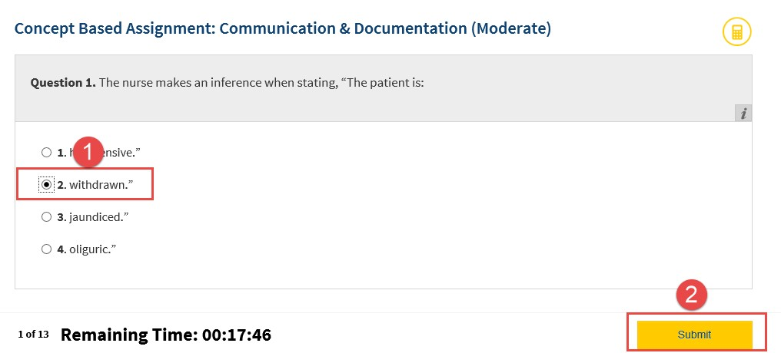

ASSIGNMENT FEEDBACK
After an assignment is completed, feedback on the assignment is available. Assignment feedback shows which questions were answered correctly or incorrectly, and provides question rationales.
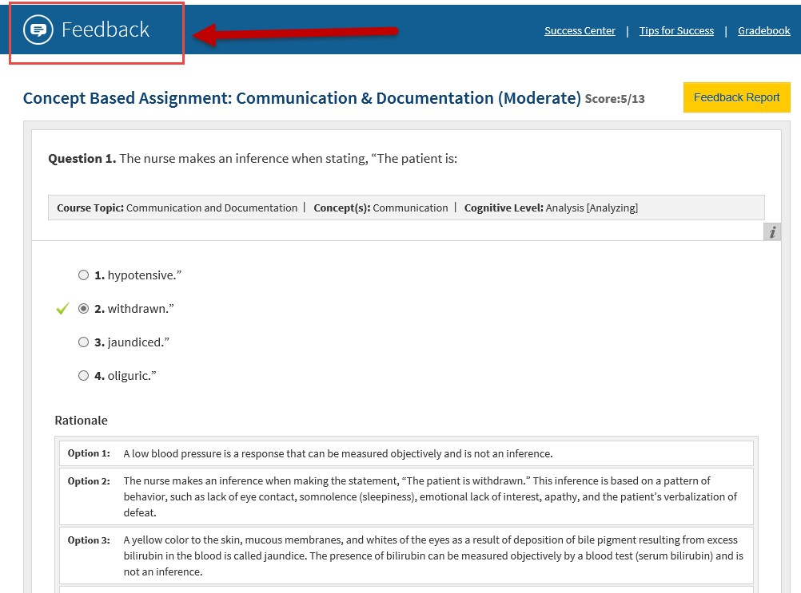

DISCUSSION FORUM
Your instructor may utilize a Discussion Forum for your class. This can be accessed via the “Discussion Forum” button at the bottom of your Success Center page.
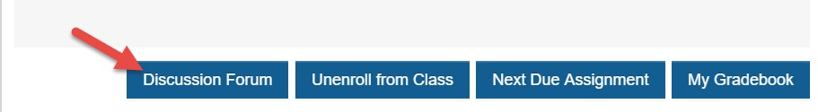

PRACTICE QUIZZES
Practice quizzes enable you to improve test taking skills and instantly know which areas to focus on for further review.

Create a Quiz
To create a Practice Quiz, students go to the Success Center and click the “Practice Quiz” button.
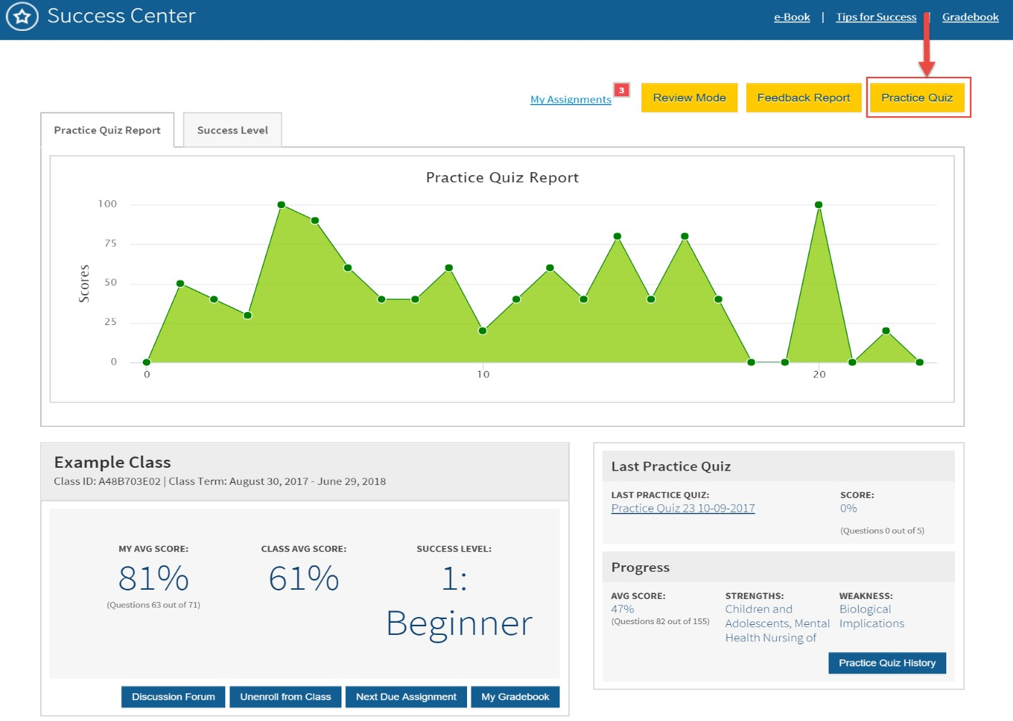

Practice Quiz Builder
From the Practice Quiz Builder page, you begin building the quiz.
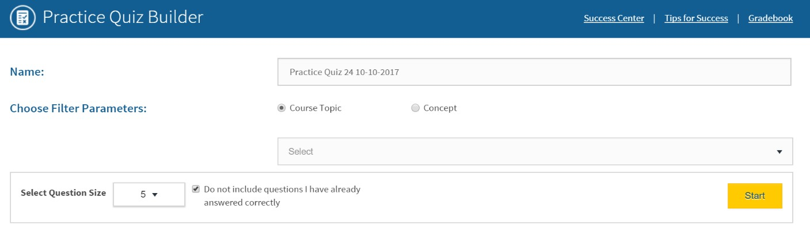

Quiz Name
Here, you can name the practice quiz.

Course Topic or Concept
You can create a quiz based on Course Topic or Concept. Click the dropdown menu to reveal the available topics or concepts. Click the checkboxes to select a single item, a combination, or all.
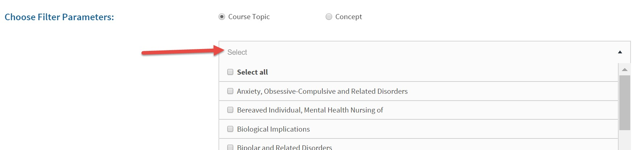

Question Size and Type
Here, you select the number of questions to include in the quiz. You can also choose to exclude questions that were answered correctly in previous quizzes. After you’ve finished making the selections, click the yellow “Start” button, which saves and opens the quiz.

Take a Quiz
To take the quiz and submit answers, students must choose an answer and click the “Submit” button.
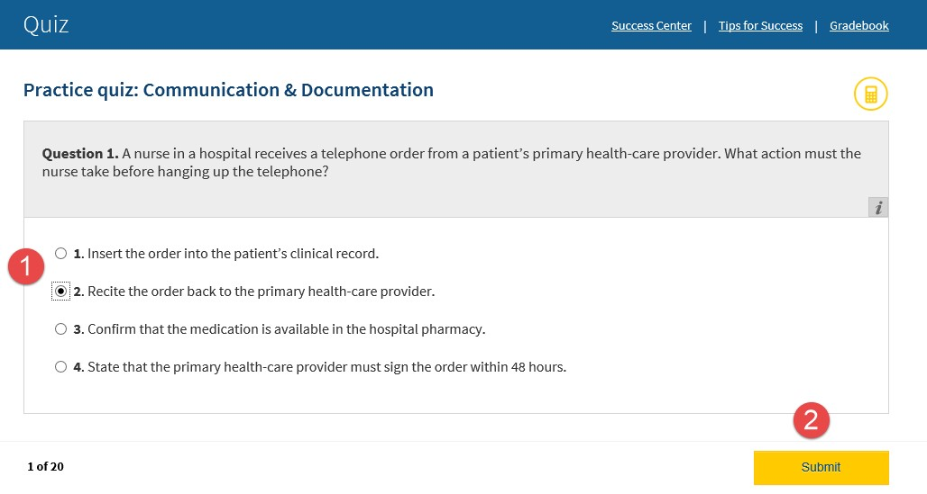

Quiz Feedback
Quiz feedback is available after a quiz is completed. Quiz feedback shows which questions were answered correctly or incorrectly and provides question rationales.
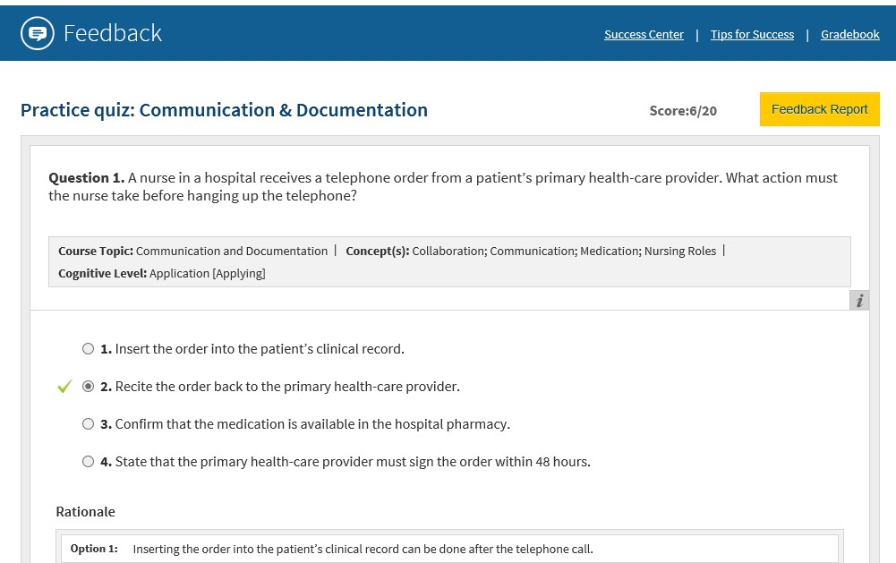

COMPREHENSIVE EXAM BUILDER (FOR NCLEX-RN®/NCLEXPN® VERSIONS ONLY)
From the “Success Center” screen, students can build a 75- or 150-question exam that pulls question topics in the same proportions that the NCLEX-RN® and NCLEX-PN® exams would.
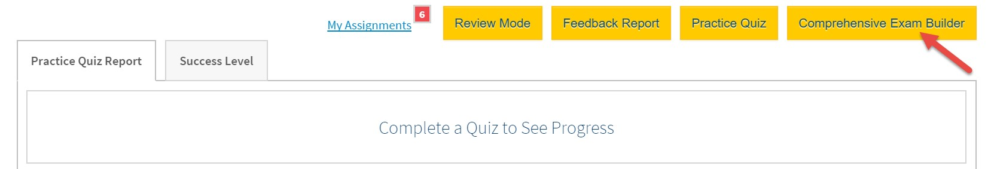

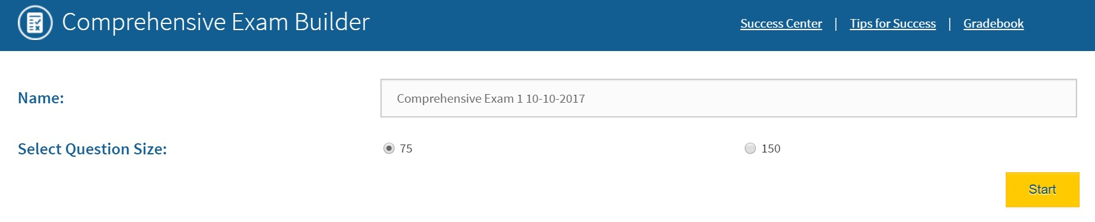

SUCCESS LEVEL GOALS
Success Level Goals are created by the instructor. To achieve a Success Level Goal, you should continue to create and take practice quizzes until the desired goal is reached.

Accessing Success Level Goals
To access the Success Level Goal, click on the “My Assignments” link on the Success Center page.

Success Level Goal
s

Ta
b

After clicking on the “My Assignments” link, click on the “Success Level Goals” tab.
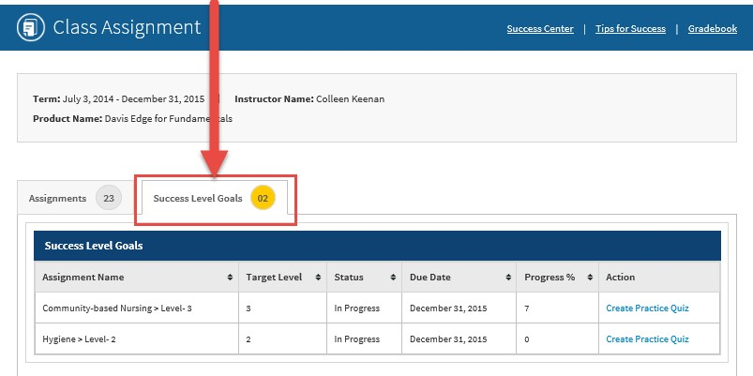

Create a Practice Quiz

To begin working towards the Success Level Goal, create a Practice Quiz by clicking on the “Create Practice Quiz” link.
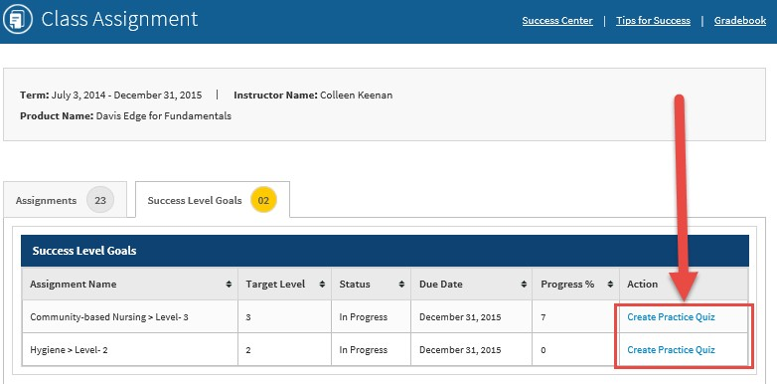

Build the Quiz

Build a Practice Quiz by (1) naming the practice quiz, (2) selecting the number of questions to be included in the quiz, and (3) clicking the “Start” button. The Course Topic cannot be edited.
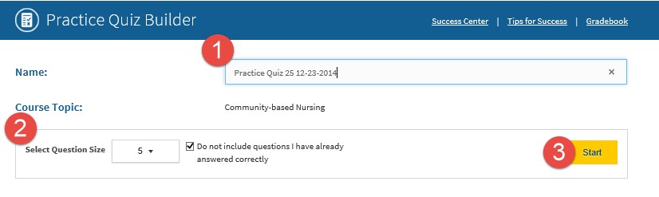

FEEDBACK REPORT
The Feedback Report displays areas of strengths and weaknesses and enables you to create a practice quiz based on area of need.

Access Feedback Report
To access the Feedback Report, click the “Feedback Report” button located on the Success Center page.

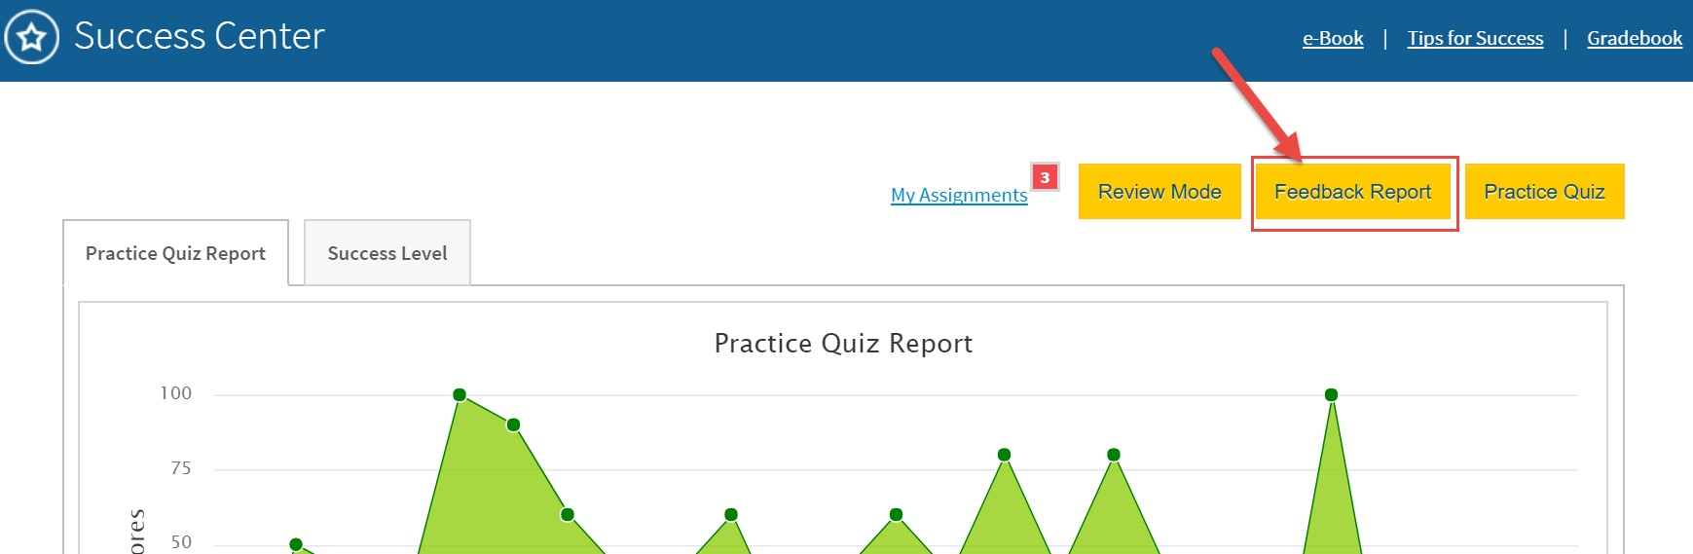

Create a Quiz Based on Areas of Weakness
From the Feedback Report, you can create a practice quiz based on (1) areas of weakness, or (2) specific topics.
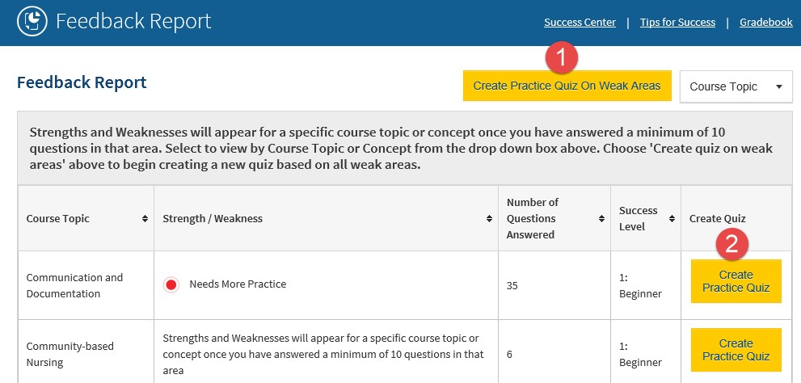

REVIEW MODE
You can access a study guide that is built from all of the correctly answered questions you have completed. You will be able to choose from filter parameters.
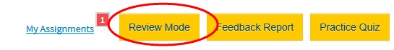

TIPS FOR SUCCESS
You can review the “Tips for Success” information by clicking the “Tips for Success” link on the Success Center. Once opened, click on an area of interest and review how you can improve test-taking skills.
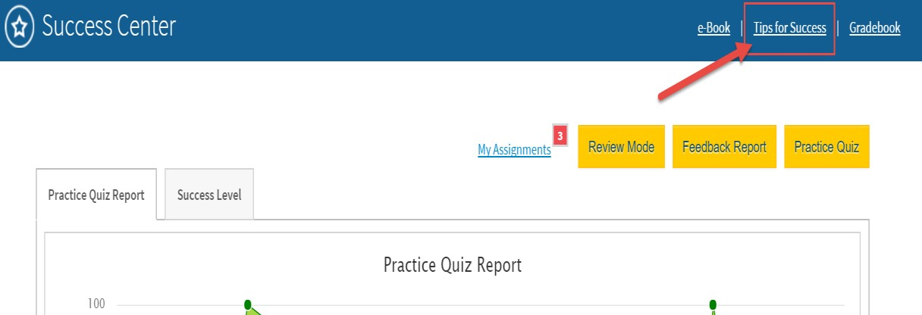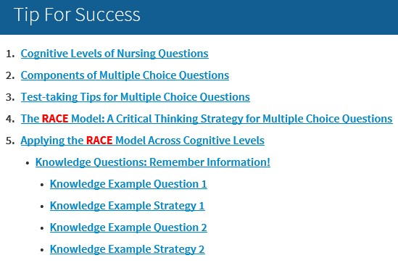

GRADEBOOK
You have access to a gradebook, which displays grades for all assignments and quizzes. To view the gradebook, click on the “Gradebook” link on the Success Center page.
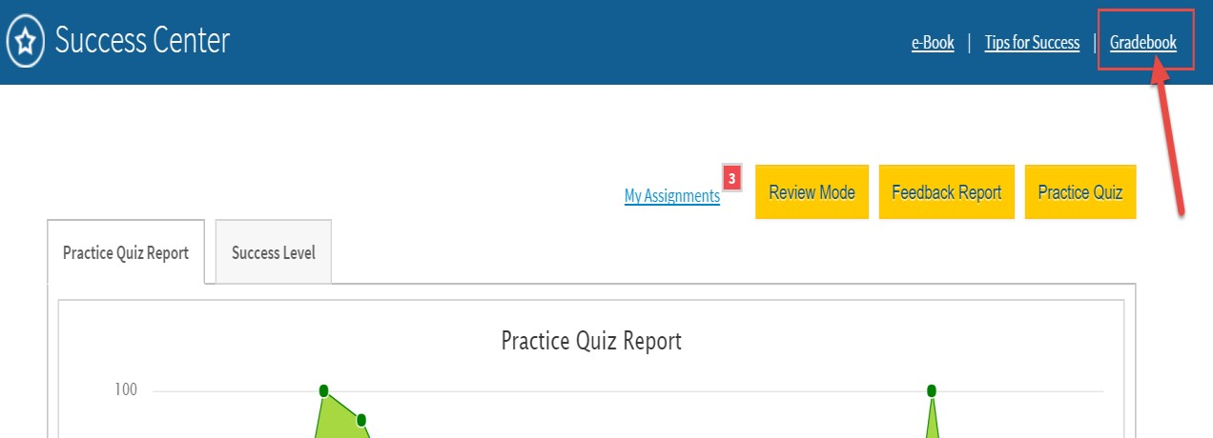

The gradebook will automatically display grades for assignments and practice quizzes.
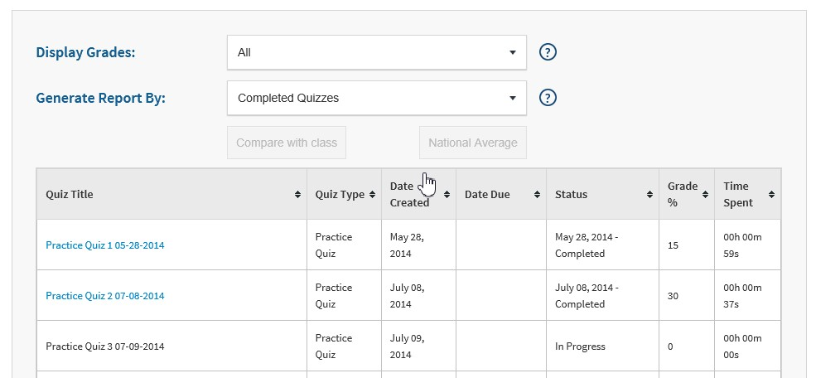

You may filter the gradebook by using the dropdown menus for (1) Display Grades, or (2) Generate Reports by features.
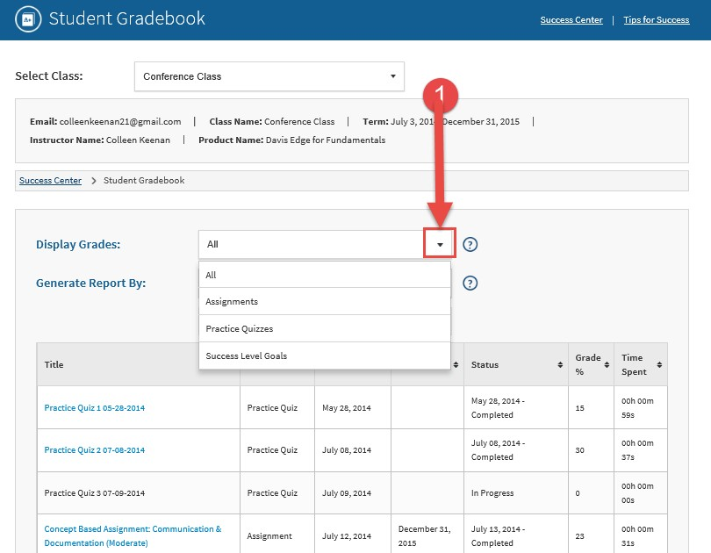

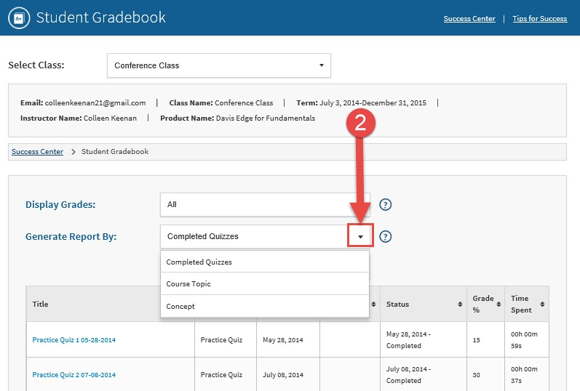

E-BOOK (FOR CERTAIN PRODUCTS)
If you are using Davis Edge for Essentials of Psychiatric Mental Health Nursing 7th Edition or Psychiatric Mental Health Nursing 9th Edition by Mary Townsend, you have access to a built-in e-Book.
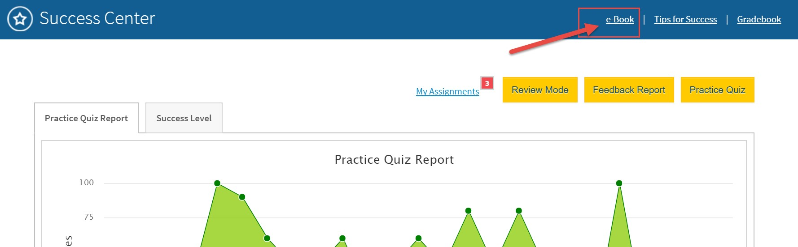

To access the e-Book, you will need a Vital Source Account. If you have an existing Vital Source Account, you can enter your credentials at the login page.
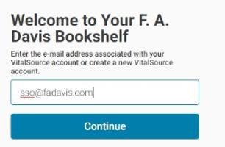

Or, you can create a Vital Source account from within Davis Edge.
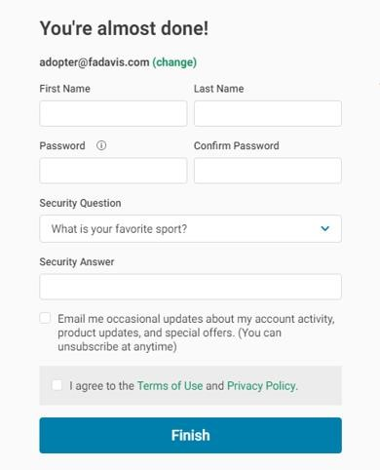

Add the book to your Vital Source bookshelf.
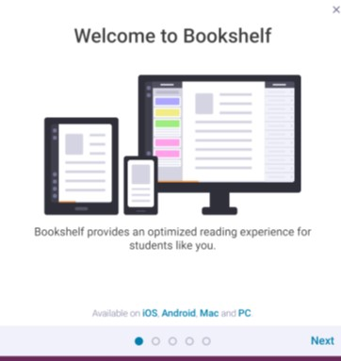

TECHNICAL SUPPORT
If students have any problems with the product, they should call 888-323-2847 or e-mail support@fadavis.com. They should also review the online Support Center, which offers helpful videos and other support information. The Support Center links can be found at the top right of the dashboard, in the drop-down menu, as well as at the bottom of the page.
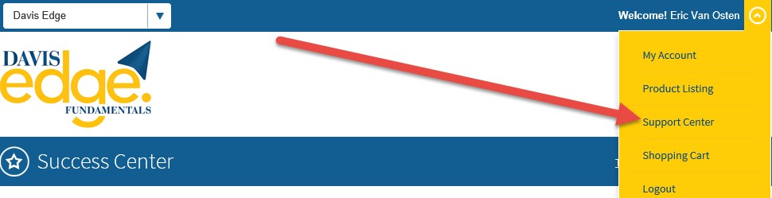

Students may choose from a variety of sources for help and support, including videos, documents, and connections to our customer service representatives.
